**1 – Daily Fluency Activity, Count to 8 (large or small group, about 3 minutes)**Daily counting practice strengthens memory. Students also benefit from connecting counting to a movement activity. Repeat this fluency activity with movements such as hopping or marching.

* Let’s clap 6 times, and count our claps! Join in when you are ready. 1, 2, 3, 4, 5, 6. (Repeat until most students are either clapping, counting, or ideally, clapping and counting. Pause between counts.)
* Let’s pat our heads 6 times, and count our pats! 1, 2, 3, 4, 5, 6. (Follow the same process as above.)
* Repeat with counting to 7 and then to 8.

**2 - Daily Fluency Activity, Count to 8 (large or small group, about 3 minutes)**

* Let’s flap our arms like birds 7 times and count our flaps! Join in when you are ready. 1, 2, 3, 4, 5, 6, 7. (Repeat until most students are either flapping, counting, or ideally, both flapping and counting. Pause between counts.)
* Let’s slap our legs 7 times and count our slaps! 1, 2, 3, 4, 5, 6, 7. (Follow the same process as above.)
* Let’s flap 8 times and count our flaps! 1, 2, 3, 4, 5, 6, 7, 8.
* Let’s slap our legs 8 times and count our slaps! 1, 2, 3, 4, 5, 6, 7, 8.

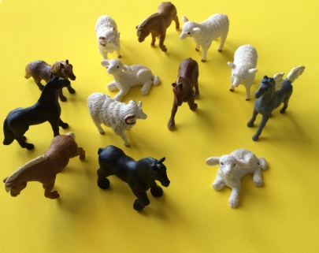**3 – Concept Review (small group, about 5 minutes)***Materials: 13 animals that can be sorted to make groups of 6 and 7 (e.g., 6 sheep and 7 horses)*

Show the mixed group of 13 animals. Elicit ideas about how to sort into two groups. Allow the students to guide the sort. Make intentional errors, putting a sheep with the horses, for example. After the sort, invite one student to touch the animals while the other students count chorally. By omitting teachers’ voices in the count, student voices strengthen and counting leadership develops within the class. This activity reviews sorting, provides a context for concept development, and asks children to count up to 7 in a linear configuration.

**4 - Concept Development, 1 More (Large Group, about 3 minutes)***Materials: Upbeat music*  
This activity is designed to practice the concept of 1 more as students use a linear configuration to count up to 7. Invite 5 students forward to create a conga line. Start the music and have children move around the room until the music stops. Then, count the number of children in the line. Invite 1 more child to join in the fun, then 1 more up to 7 students. Each time 1 more child joins the line, ask the how many question after counting. Repeat the activity with different dancers, as time allows, so all students have an opportunity to participate in the conga line.

**5 - Concept Development, Touch and Count (Small Group, about 3 minutes)**Each child needs a baggie with 8 cotton balls or other identical materials. Any material is fine (beans, pompoms, blocks, etc.) so long as it is different from past touch & count activities. Repeat the same differentiated counting activity from last week, using a new material. Note: Be specific in feedback to students, “Yesterday, you counted to 5. Today you counted to 8! You did it quickly and with more confidence!” It is also wise to document progress with counting to show parents. Take note if students count more effectively with some materials than others.

**6 - Fluency Practice, Build and Break a Stick (Small Group, about 3 minutes)***Materials: one set of numeral cards 1–8 per group, 4 stick of 5 cubes each (varied colors, 1 stick per child), loose cubes*  
Note: This fluency activity allows students to have another experience of composition, putting together, and decomposition.  
Gather a group of 4 children and provide each child with a stick of 5 unifix cubes to:

* Touch and count the cubes of your stick. (Pause to allow for student response.) Now, let me hear you counting as you build! (1, 2, 3, 4, 5) Now, add 1 more! (Repeat until children have built a stick of 8 cubes).
* Break your stick apart in different ways and then put it back together again. (Circulate and provide support as students work.) How many cubes are in your stick when you put it back together?
* Have the students break their sticks again in a different way. Be sure to show them the numerals from 1 to 8. Ask them which shows the number 8, to help connect their composition to the numeral.  
  This fluency activity, just as in a previous lesson, asks students to build their stick of 8 cubes starting with 5 and putting first 1 more to make 6 and then 1 more to make 7, and finally 1 more to make 8. When they break their sticks, encourage students to see the familiar numbers inside 8. “Look, when you broke your stick, you made a little one! How many cubes are in that one?”

**7 – Concept Development (small group, about 5 minutes)**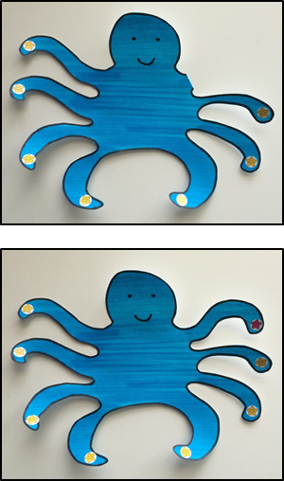Working with a small group (no more than 6 children), show students an octopus pattern with one arm hidden from view (bend arm back). Say, “This is Ollie Octopus! Let’s count his arms.”

* Touch each arm as students count to 7. Say, “I’ll put a sticker on each arm as you count again.” Students count, “1, 2, 3, 4, 5, 6, 7.”
* After placing the last sticker, unbend the hidden arm and say, “Wait! He has 1 more arm! I’ll touch while you count together: 1, 2, 3, 4, 5, 6, 7, 8.”
* (Fold back the eighth arm.) Ask, “What is 7 and 1 more (unfold the arm)? Say, “Let’s put on 1 more sticker.” Place the sticker and have students count again, “1, 2, 3, 4, 5, 6, 7, 8.”
* Ask, “How many stickers does Ollie have now?” Lead students to use a complete sentence, “Ollie has 8 stickers.”
* (Fold back the eighth arm.) Say, “Yes! So, 7 and 1 more is… (unfold the eighth arm)?” “8!”

**8 – Build it, roll it, write it: Writing Number 8**   
Consult the HWT Manual to learn the specific way that the numbers must be taught, then work with small groups of children to:

* Build the number 8 with wooden pieces. (Video support [here.](https://www.youtube.com/watch?v=cioBT3DbWTI)))
* Make the number 8 with Roll-A-Dough. (Video support [here.)](https://www.youtube.com/watch?v=3AoWMqUc1xQ)
* Write the number 8 in HWT journals. After children draw a picture related to the number, have them practice writing the number 8 on the page’s HWT strip.

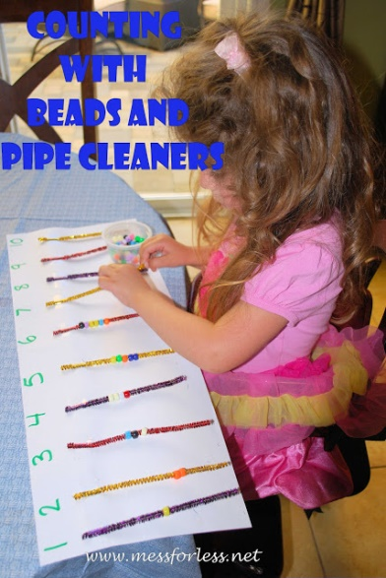

**9 – Additional Learning Centers  
  
Ollie Octopus** - Invite children to make Ollie Octopus in the art center. For each student, provide a paper plate with 8 hole punches and a set of 8 chenille stems with a knot on one side. Have children count the chenille stems before and after they thread them through the circle. Students might also enjoy painting Ollie Octopus or decorating him with materials from the art cart; does anyone want to make Olivia Octopus instead?

**Pipe Cleaners & Beads** - Build numeral recognition, encourage 1:1 correspondence and boost fine motor skills by creating a center where children can count beads and thread them onto pipe cleaners. When creating the poster board, please use numerals 1-8.